Octagonal Trapezohedron

Definition
# Source: AI Source: Provided by: [Data Path: Persons Table -> ID Column: 1, Name_En Column: Motasem Essam] -> From: [ChatGPT] on [7/25/2026]
An Octagonal Trapezohedron is a convex polyhedron consisting of 16 congruent kite-shaped faces, arranged symmetrically around a central eightfold rotational axis.
It has two opposite axial vertices (one at each end of the axis) and eight vertices forming a middle ring.
It is also called an Octagonal Deltohedron.

Simple Definition
# Source: AI Source: Provided by: [Data Path: Persons Table -> ID Column: 1, Name_En Column: Motasem Essam] -> From: [ChatGPT] on [7/25/2026]
An octagonal trapezohedron is a three-dimensional solid made of sixteen identical kite-shaped faces arranged around a central axis, with eight vertices forming a ring around its middle.
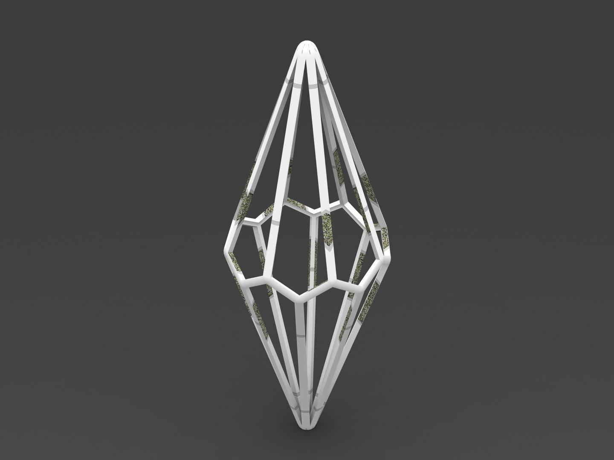

Geometric Structure
# Source: AI Source: Provided by: [Data Path: Persons Table -> ID Column: 1, Name_En Column: Motasem Essam] -> From: [ChatGPT] on [7/25/2026]
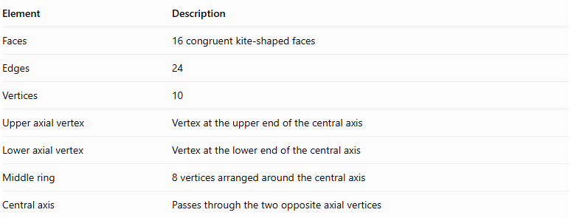
Element | Description
Faces | 16 congruent kite-shaped faces
Edges | 24
Vertices | 10
Upper axial vertex | Vertex at the upper end of the central axis
Lower axial vertex | Vertex at the lower end of the central axis
Middle ring | 8 vertices arranged around the central axis
Central axis | Passes through the two opposite axial vertices

Face Structure
# Source: AI Source: Provided by: [Data Path: Persons Table -> ID Column: 1, Name_En Column: Motasem Essam] -> From: [ChatGPT] on [7/25/2026]
Each face is a kite-shaped quadrilateral characterized by:
- Two pairs of adjacent equal-length sides.
- One pair of equal opposite angles.
- Perpendicular diagonals.
- One diagonal that bisects the other.
All sixteen faces are congruent and form a closed convex surface.

Edge Structure
# Source: AI Source: Provided by: [Data Path: Persons Table -> ID Column: 1, Name_En Column: Motasem Essam] -> From: [ChatGPT] on [7/25/2026]
The 24 edges can be classified into three groups:
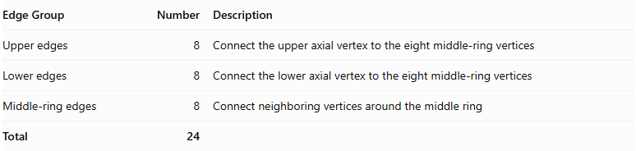
Edge Group | Number | Description
Upper edges | 8 | Connect the upper axial vertex to the eight middle-ring vertices
Lower edges | 8 | Connect the lower axial vertex to the eight middle-ring vertices
Middle-ring edges | 8 | Connect neighboring vertices around the middle ring
Total | 24

Vertex Structure
# Source: AI Source: Provided by: [Data Path: Persons Table -> ID Column: 1, Name_En Column: Motasem Essam] -> From: [ChatGPT] on [7/25/2026]
The octagonal trapezohedron has ten vertices:
- 1 upper axial vertex.
- 1 lower axial vertex.
- 8 middle-ring vertices.
$$V=2+8=10$$
In its standard symmetric form:
- Eight faces meet at each axial vertex.
- Four faces meet at each middle-ring vertex.

Mathematical Properties
# Source: AI Source: Provided by: [Data Path: Persons Table -> ID Column: 1, Name_En Column: Motasem Essam] -> From: [ChatGPT] on [7/25/2026]
For an octagonal trapezohedron, $n=8$.

A. Number of Faces
# Source: AI Source: Provided by: [Data Path: Persons Table -> ID Column: 1, Name_En Column: Motasem Essam] -> From: [ChatGPT] on [7/25/2026]
$$F=2n=2(8)=16$$

B. Number of Edges
# Source: AI Source: Provided by: [Data Path: Persons Table -> ID Column: 1, Name_En Column: Motasem Essam] -> From: [ChatGPT] on [7/25/2026]
$$E=3n=3(8)=24$$

C. Number of Vertices
# Source: AI Source: Provided by: [Data Path: Persons Table -> ID Column: 1, Name_En Column: Motasem Essam] -> From: [ChatGPT] on [7/25/2026]
$$V=n+2=8+2=10$$

D. Euler's Formula
# Source: AI Source: Provided by: [Data Path: Persons Table -> ID Column: 1, Name_En Column: Motasem Essam] -> From: [ChatGPT] on [7/25/2026]
$$V-E+F=2$$
$$10-24+16=2$$
<badge color="success">Verified</badge> Euler's formula is satisfied.

Symmetry
# Source: AI Source: Provided by: [Data Path: Persons Table -> ID Column: 1, Name_En Column: Motasem Essam] -> From: [ChatGPT] on [7/25/2026]
A standard symmetric octagonal trapezohedron has:
- An eightfold rotational symmetry axis.
- Eightfold rotational symmetry around its central axis.
- Eight vertical reflection planes containing the central axis.
- Central inversion symmetry when its upper and lower portions are arranged symmetrically.

Constructing Octagonal Trapezohedron in Solid Geometry

Geometric Instruments Used
# Source: AI Source: Provided by: [Data Path: Persons Table -> ID Column: 1, Name_En Column: Motasem Essam] -> From: [ChatGPT] on [7/25/2026]
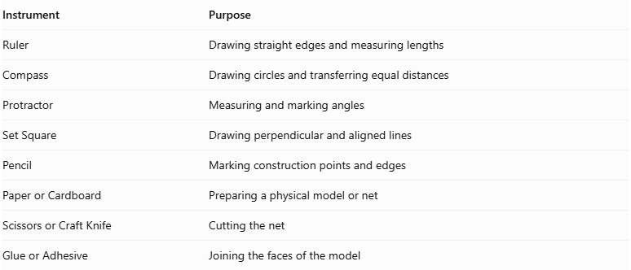
Instrument | Purpose
Ruler | Drawing straight edges and measuring lengths
Compass | Drawing circles and transferring equal distances
Protractor | Measuring and marking angles
Set Square | Drawing perpendicular and aligned lines
Pencil | Marking construction points and edges
Paper or Cardboard | Preparing a physical model or net
Scissors or Craft Knife | Cutting the net
Glue or Adhesive | Joining the faces of the model

Instrument-Based Construction Procedures
# Source: AI Source: Provided by: [Data Path: Persons Table -> ID Column: 1, Name_En Column: Motasem Essam] -> From: [ChatGPT] on [7/25/2026]
The octagonal trapezohedron can be constructed using geometric instruments through a symmetry-based drawing process.

Preparing the Central Axis
# Source: AI Source: Provided by: [Data Path: Persons Table -> ID Column: 1, Name_En Column: Motasem Essam] -> From: [ChatGPT] on [7/25/2026]
- Draw a vertical reference line representing the central axis.
- Mark the intended upper and lower axial vertices.
- Establish the central region where the two staggered vertex rings will be positioned.

Constructing the Two Vertex Rings
# Source: AI Source: Provided by: [Data Path: Persons Table -> ID Column: 1, Name_En Column: Motasem Essam] -> From: [ChatGPT] on [7/25/2026]
- Use a compass to draw the reference circles for the upper and lower rings.
- Divide each circle into eight equally spaced positions.
- Use a protractor to mark the eight positions at equal angular intervals of ${45}^{∘}$.
- Offset the second ring relative to the first to create the staggered arrangement.
- Mark the eight vertices on each ring.

Marking the Axial Vertices
# Source: AI Source: Provided by: [Data Path: Persons Table -> ID Column: 1, Name_En Column: Motasem Essam] -> From: [ChatGPT] on [7/25/2026]
- Mark the upper axial vertex above the upper ring.
- Mark the lower axial vertex below the lower ring.
- Align both vertices with the central axis.

Constructing the Kite-Shaped Faces
# Source: AI Source: Provided by: [Data Path: Persons Table -> ID Column: 1, Name_En Column: Motasem Essam] -> From: [ChatGPT] on [7/25/2026]
- Connect the upper axial vertex to the appropriate vertices of the upper and lower rings.
- Connect the lower axial vertex to the corresponding vertices of the two rings.
- Join neighboring vertices from the two rings according to the trapezohedron's face arrangement.
- Form sixteen kite-shaped quadrilateral faces.
- Check that all shared edges have matching lengths and that the faces close into a convex solid.

Completing the Three-Dimensional Drawing
# Source: AI Source: Provided by: [Data Path: Persons Table -> ID Column: 1, Name_En Column: Motasem Essam] -> From: [ChatGPT] on [7/25/2026]
- Draw the visible edges using continuous lines.
- Represent hidden edges using dashed lines when necessary.
- Check that all sixteen faces are connected correctly.
- Verify that the drawing contains 18 vertices and 32 edges.
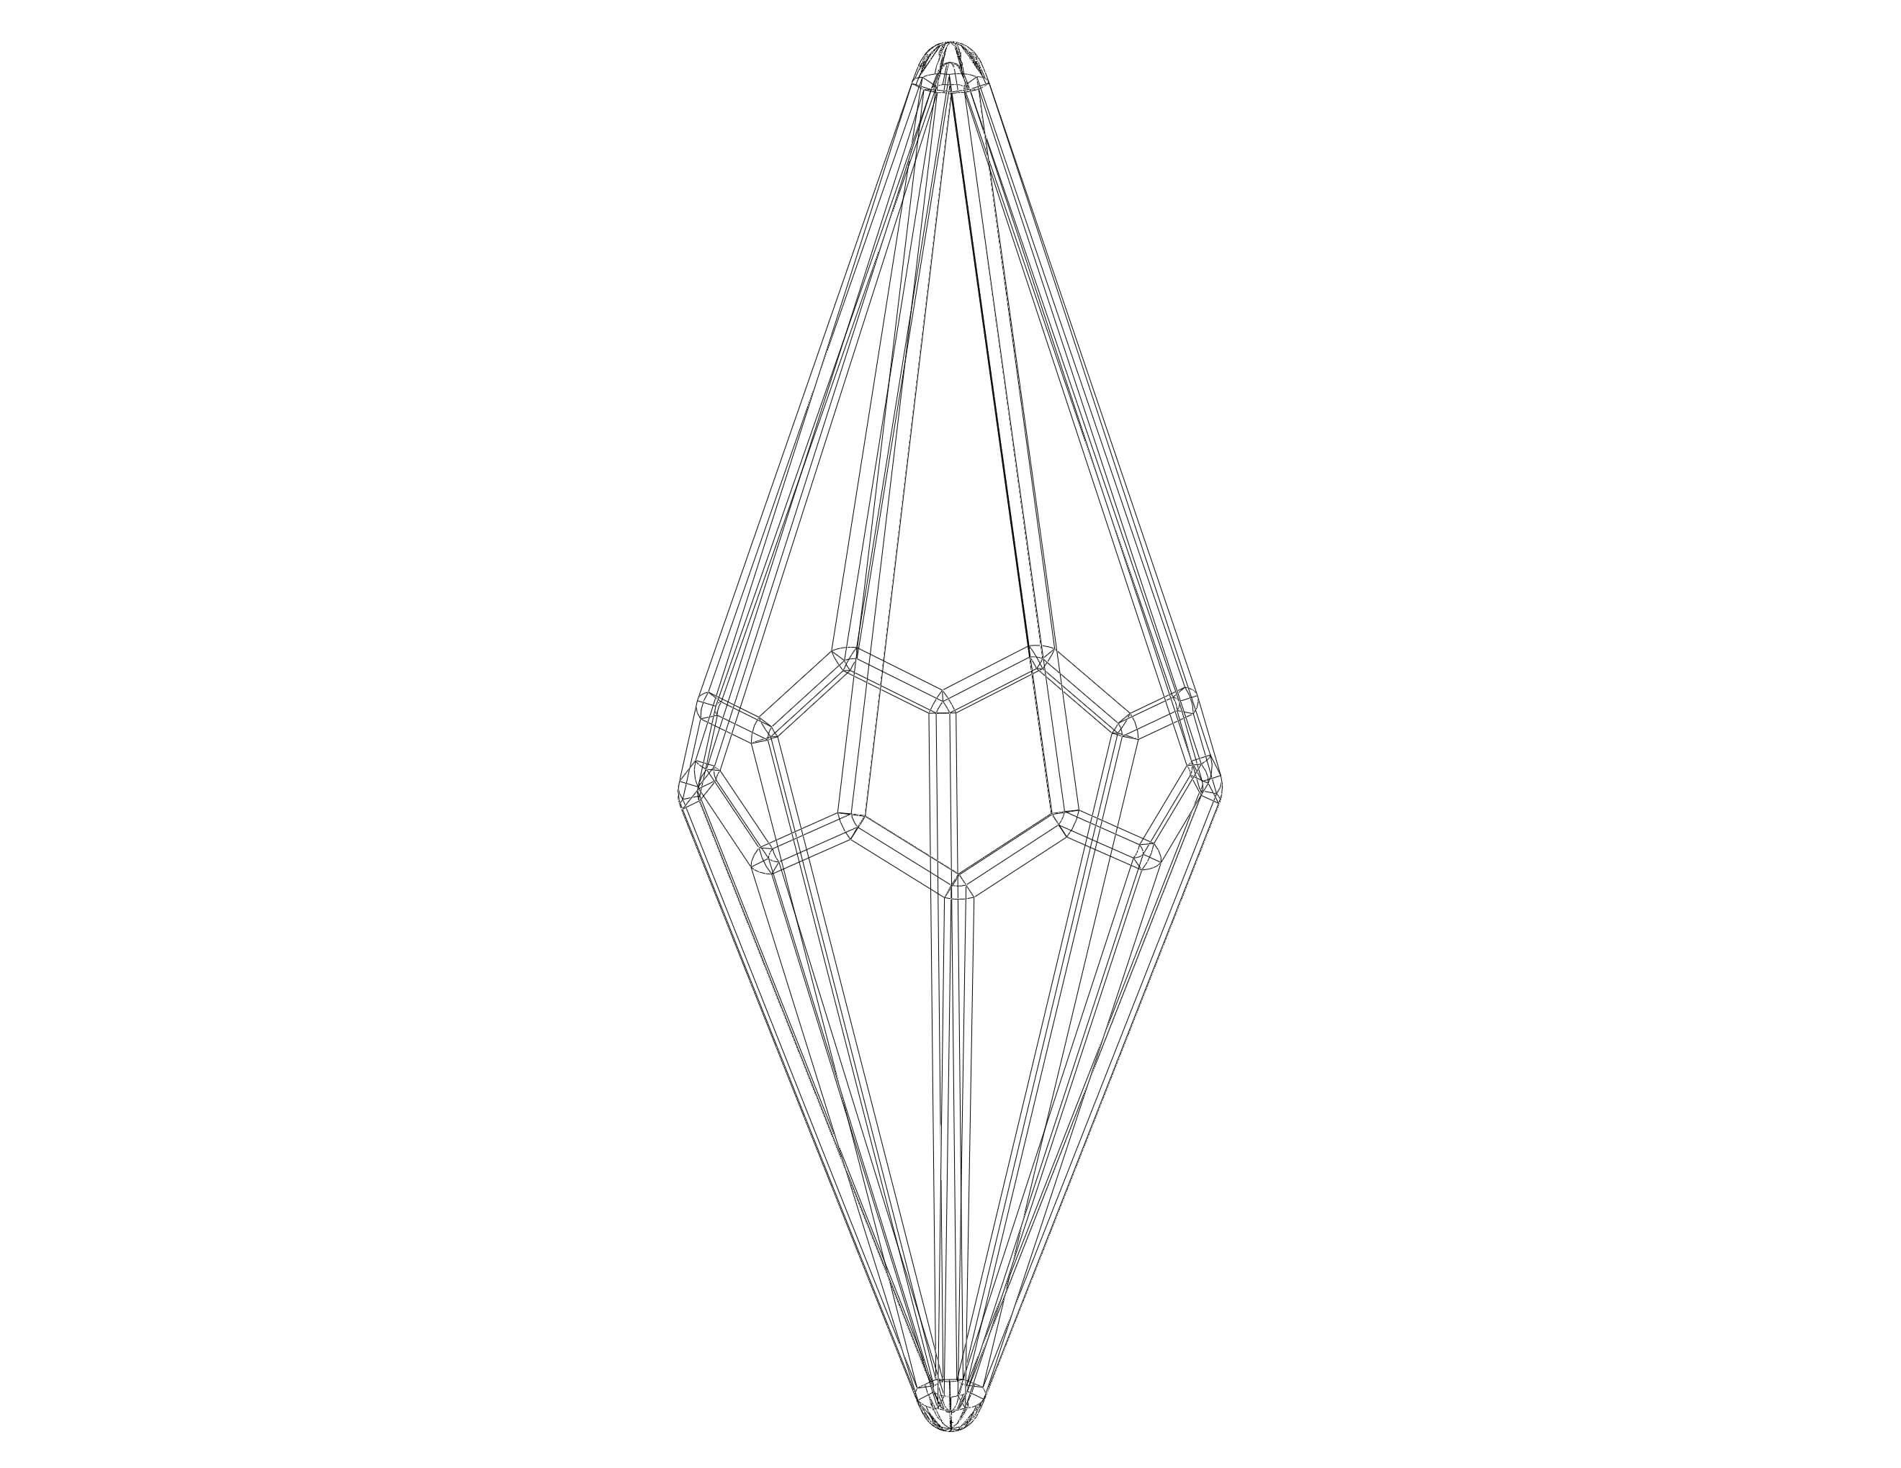

Constructing a Physical Model
# Source: AI Source: Provided by: [Data Path: Persons Table -> ID Column: 1, Name_En Column: Motasem Essam] -> From: [ChatGPT] on [7/25/2026]
- Draw a valid net containing sixteen correctly connected kite-shaped faces.
- Add tabs along selected outer edges.
- Cut out the net carefully.
- Fold along the shared face boundaries.
- Join corresponding edges using adhesive.
- Check that the assembled model forms a closed octagonal trapezohedron.
Construction note: This is an instrument-based geometric construction using rulers, compasses, protractors, and geometric relationships. It does not use coordinate-based construction.

Relationship to Other Trapezohedra
# Source: AI Source: Provided by: [Data Path: Persons Table -> ID Column: 1, Name_En Column: Motasem Essam] -> From: [ChatGPT] on [7/25/2026]
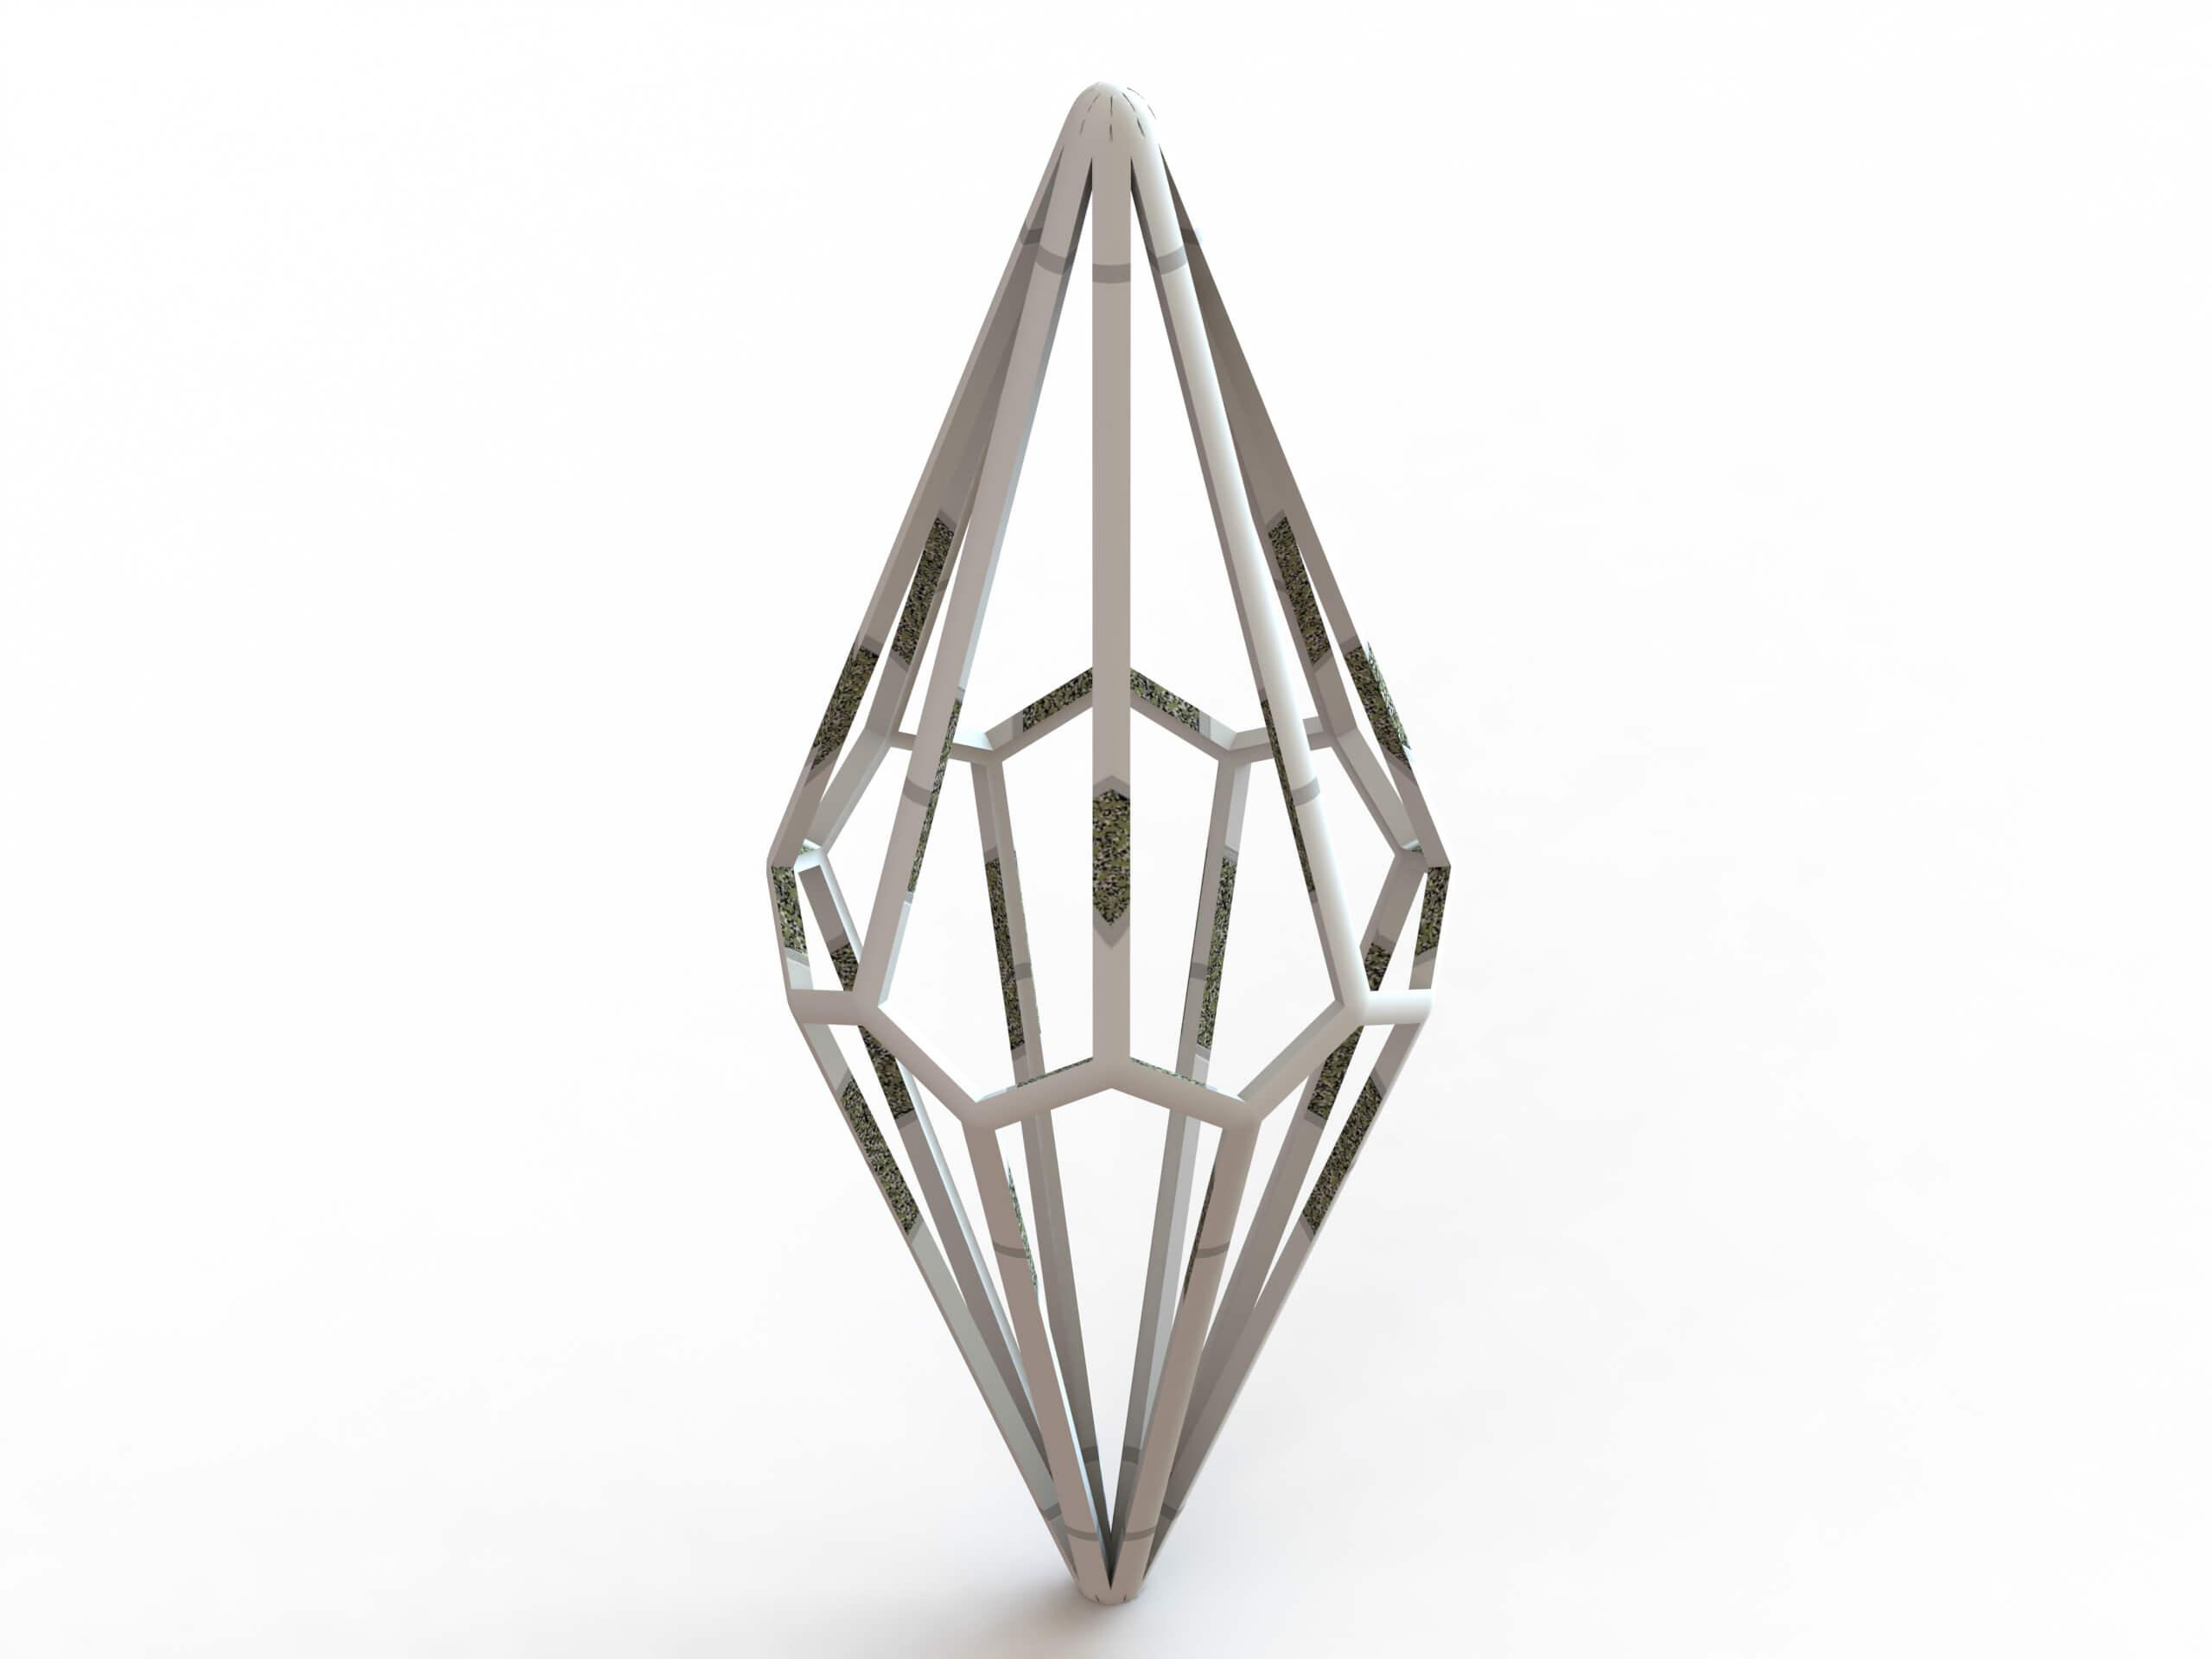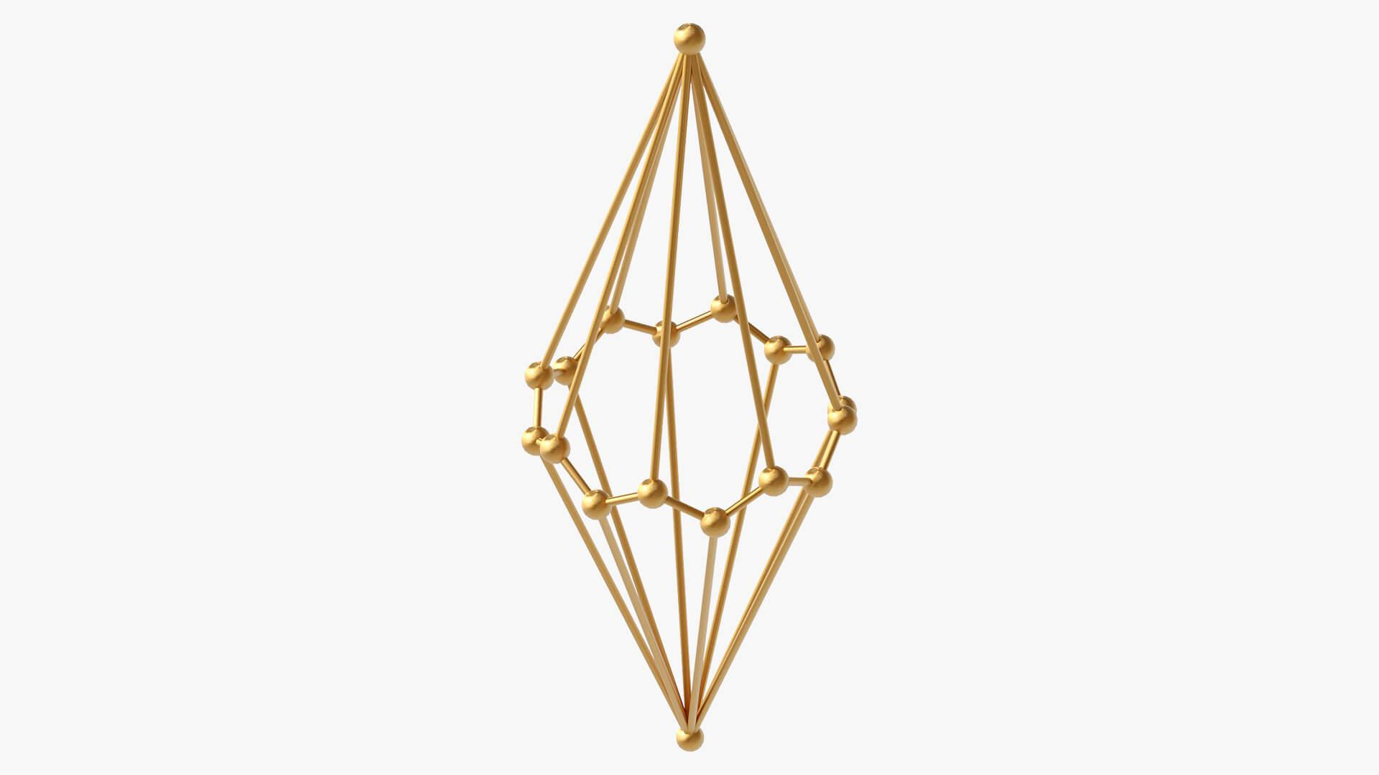
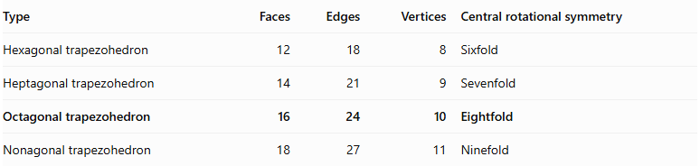
Type | Faces | Edges | Vertices | Central rotational symmetry
Hexagonal trapezohedron | 12 | 18 | 8 | Sixfold
Heptagonal trapezohedron | 14 | 21 | 9 | Sevenfold
Octagonal trapezohedron | 16 | 24 | 10 | Eightfold
Nonagonal trapezohedron | 18 | 27 | 11 | Ninefold

Mathematical Classification
# Source: AI Source: Provided by: [Data Path: Persons Table -> ID Column: 1, Name_En Column: Motasem Essam] -> From: [ChatGPT] on [7/25/2026]
For an $n$-gonal trapezohedron:
$$F=2n, E=3n, V=n+2$$
For the octagonal form:
$$n=8$$
Therefore:
$$\boxed{F=16, E=24, V=10}$$

Key Points
# Source: AI Source: Provided by: [Data Path: Persons Table -> ID Column: 1, Name_En Column: Motasem Essam] -> From: [ChatGPT] on [7/25/2026]
- An octagonal trapezohedron has 16 congruent kite-shaped faces.
- It has 24 edges and 10 vertices.
- Eight vertices form its middle ring.
- Two vertices lie at opposite ends of its central axis.
- Its standard symmetric form has an eightfold rotational axis.
- It satisfies Euler's polyhedron formula.

Conclusion
# Source: AI Source: Provided by: [Data Path: Persons Table -> ID Column: 1, Name_En Column: Motasem Essam] -> From: [ChatGPT] on [7/25/2026]
The Octagonal Trapezohedron is the eightfold form of a trapezohedron, consisting of sixteen congruent kite-shaped faces arranged around a central axis. It has ten vertices, twenty-four edges, and eightfold rotational symmetry.
Classification note: The octagonal trapezohedron is topologically equivalent to a bipyramid over an octagon, but its faces are kite-shaped quadrilaterals rather than triangles.

